


Tenant Fitout and Minor Alterations Guide

October 2023

Contents
- Overview
- Planning your fitout
- Planning your indoor environment
- Designing an effective tenancy fitout
- Fitout objectives
9 Consultation and approval of fitout plans
11 As built drawings and commissioning data
11 Alterations to base building
12 Building services
14 Waste and recycling in your tenancy
17 Workplace health and safety
18 Works undertaken within your tenancy
19 Works undertaken within base building areas
24 Emergency action
26 Fitout checklist

Investa | Tenant Fitout and Minor Alterations Guide 2



We work with tenants to enable a streamlined transition to their new workplace. Our Projects and Sustainability teams can provide
value-add services to tenants, who seek a more efficient, sustainable fitout for their workplace.

Overview
The building Tenant Fitout and Minor Alterations Guide has been prepared to inform tenants, project managers, architects, consultants, and contractors of the procedures for having building and services works approved and implemented at the building.
Prior to submitting a written request for fitout alteration approval, tenants and designers should familiarise themselves with the contents of this manual.
- The works shall be carried out at the tenant’s risk by an approved tenant appointed Project Manager and / or builder. All works also require approval by the Building Management Team to ensure compliance with Investa policies and standards. This ensures all fitout requirements are in accordance with the conditions of all permits, approvals, consents, and statutory requirements by relevant authorities.
- The tenant shall pay on demand all costs, fees and expenses incurred by the Building Management Team including, without limitation, the fees of its architects and services consultants associated with advice received, review of drawings, overseeing installation works where necessary, and producing “As Installed” drawings should they not be issued at the completion of the works.
- The tenant shall pay on demand any Building Management Team costs associated with the air-conditioning system data base changes, DDC programming, display page modifications and assistance with controls engineering i.e. Compilation of VAV schedules and I/O sheets. These works are to be performed by Siemens only.
- The tenant shall pay on demand all costs, fees and expenses incurred by the Building Management Team for any False Alarm of Fire, determined by the landlord to be due to contractor(s) negligence and/or failure to follow set procedures throughout the course of any tenancy fitout installation or alterations.
- The tenant shall rectify any damage done to the building or pay on demand any costs associated with rectification of damage to the building, due to tenancy fitout and/or works being carried out within the building.
- Should a situation or question arise in relation to any matter not covered in these policy guidelines, please contact the Building Management Team for clarification.

Planning your fitout
Global research, including that of the World Green Building Council, have identified that a well-designed interior office space can have positive impacts on the health and wellbeing and performance of employees¹.
According to the Harvard School of Public Health, people working in “green offices have significantly higher cognitive functioning scores²”, leading to employees who are more alert, more engaged and more likely to perform at their best.
Tenants are encouraged to design the fitout of their Premises in a sustainable way that considers:
- Minimising water, electricity, and waste usage.
- Use of sustainable materials including low VOC, recyclable.
- Design concepts that have a positive health impact on the space’s occupants.
The Fitout section of Investa’s Online Sustainability Toolkit provides dynamic, best practice guidelines to enable the creation of such a sustainable and productive workspace.
If you, or your design team would appreciate guidance, please contact your Building Management Team, who can connect you with your Investa Sustainability Team.

Impact of healthy workplaces on employee satisfaction

Input Output Added value
a1
•
•
Healthy workplaces
Health and wellbeing
b1
Costs, risks and sacrifices
of interventions
Individual benefits
- Better health and wellbeing
- Better quality of life
Benefits for the organisation
Physical
environment
1
2
- Healthier employees
- Less sick leave
- Increased employee satisfaction
- Increased productivity
a2
•
•
•
Employee satisfaction
Productivity Cost
b2
Societal benefits
•
•
Fewer labour market dropouts
Lower health care costs
Costs
of interventions, implementation and management-in-use

Source: The impact of healthy workplaces on employee satisfaction, productivity and costs | Emerald Insight.

- ‘The Business Case for Green Building’, a report from WGBC, 2013. http://www.worldgbc.org/search/content/business%20case
- Allen, J. G. (2017). Research: Stale Office Air Is Making You Less Productive. Harvard Business Review.

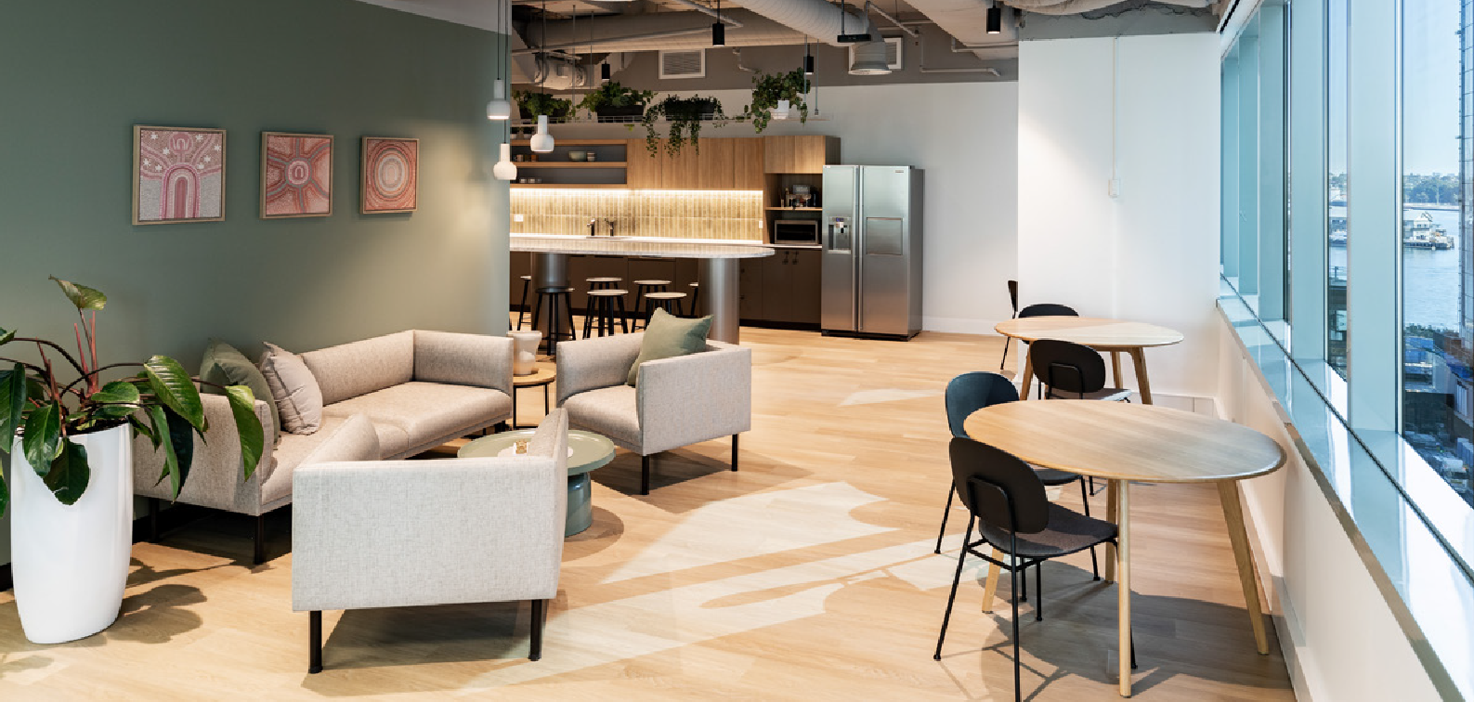

Planning your indoor environment
Moving into, or refurbishing tenancy space provides an excellent opportunity to create an office that reflects your business culture and approach, whilst improving the comfort and productivity of all the people in the office and saving money on running costs.

Key factors to consider


Your business
The likely life of your fitout in the building and your business plans – will your business needs change significantly during the term of your lease?


Work practice
Changing work practices and culture - your office reflects your corporate culture. Will it be equitable and open plan or hierarchical and highly partitioned?


Productivity
Mental alertness and better decision making comes from a healthy, daylit office.

Technology
New technology coming to market will impact how people expect to work in the future.


Amenity and flexibility
What services do you need to factor in when planning your space to ensure people can work effectively?

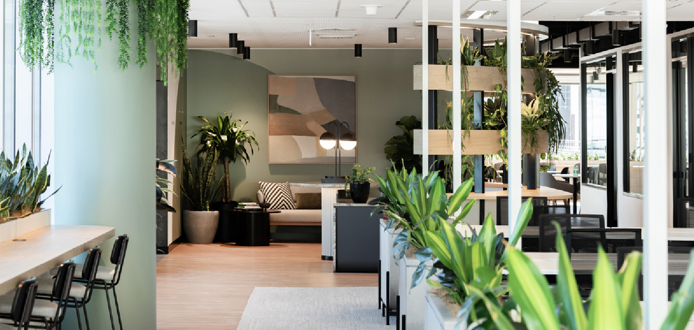

Designing an effective tenancy fitout
Investa recommends that the following principles be incorporated into any interior designer or space planners brief for your interior fitout.

Investa high performance standards
Investa offers comprehensive High Performance Design Guidelines aimed at reducing the embodied carbon in both base building and tenancy upgrades. We provide expert support to assist you in achieving optimal business fitouts.
By engaging with Investa early in the process, you can tap into the insights of our knowledgeable team. With a vast portfolio of more than 500 tenants throughout Australia, Investa possesses extensive expertise in achieving successful interior fitouts while minimising embodied carbon and its environmental impact.
Embodied Carbon refers to the carbon emissions linked with the manufacturing and utilisation of materials in construction endeavours.

Further information and best practice guides
The Better Buildings Partnership Program (BBP) provides an online Leasing Lifecycle Tool. This tool provides a wide range of best practice documents, advice, information, and case studies, including a section on interior design and fitouts.
Investa recommends that anyone considering a new fitout or refurbishment makes use of this free tool: http://www.betterbuildingspartnership.com.au/leasing-lifecycle-tool/



Fitout objectives
Investa and their tenants mutually commit to the following collaborative objectives when planning fitouts.

Occupant comfort and operating costs
Design your office to allow for balance air flow across the floor, ensuring everyone experiences a comfortable environment. Reducing the number of partitions, walls and separate offices
can improve comfort, reduce energy use and costs associated with running the tenancy air- conditioning systems.

Maximise daylight and optimise lighting
Access to daylight for all employees is vital for productivity. Open plan offices should be located to provide the best light and views for the majority of employees. Plan for lighting levels to match activities and space use, whilst reducing energy use, through smart, low energy fittings and sophisticated controls.


Reuse and recycling
How materials are used in your fitout might be cost-effectively updated and eventually reused or recycled later.

Healthy materials
Choose a selection of low impact, healthy materials that improve air quality for employees. Materials with high volatile organic compounds (VOC’s) and airborne pollutants should be avoided.


Green office
Use the opportunity to create a green office – a GreenStar Interiors Certification guarantees you will achieve a quality, healthy indoor environment and receive recognition for your office.


Allow for plants in the office design
Plants are an effective way to add colour, improve local air quality and improve the mood and productivity of the office.

Tenant lighting
Tenants installing their own lighting must use an efficient, leading-edge occupancy-based lighting system with comprehensive occupancy based controls. The lighting system should have suitable zoning and daylight integration. Investa will make reasonable efforts to support the tenant in choosing efficient, best-practice occupancy-based lighting.


Supplementary air conditioning
The tenant can only install energy efficiency supplementary air conditioning which is specified for maximum efficiency and the tenant will arrange for regular maintenance and annual reviews of set points and timers. The tenant will install and use temperature sensors and timers or
occupancy sensors to control energy use. Where the tenant’s supplementary air conditioning units are water sourced and connected to the base building systems, a solenoid valve must be installed and programmed to ensure the water flow is stopped when the compressor is cycled off.
The alterations made to air conditioning during the tenancy fitout need to be carefully managed in consultation with a mechanical engineer to ensure the tenancy space is comfortable for the life of the fitout. It is common when tenancy walls are placed up alterations to sensors, air registers and air flows need to be updated, and meeting rooms often need supplementary air and package air conditioning units installed.


Water fixtures
The tenant will install water-efficient fixtures, taps, showerheads, toilets and urinals.


Paints, finishes, and adhesives
The tenant will use natural (plant-based) or Low-VOC interior wall paints, varnishes, stains and enamels. Investa’s Online Sustainability Toolkit contains more information on low toxin fitout choices.


Minimising fitout waste
Investa will provide advice to assist the tenant to dispose of fitout waste and waste resulting from doing works in the building or the premises in a sustainable way so as to reduce the total environmental impact of tenants’ fitout.
- During tenancy fitout construction Investa encourages tenants and contractors to reuse materials on site where practicable.
- In addition to recycling fitout and de-fit waste, Investa will collaborate with tenants to explore re-purposing old, unwanted office furniture at the conclusion of a tenant’s lease, providing it to charities, NGOs and small start-ups, unable to access such office equipment themselves.
- To ensure that such an initiative can take place, Investa and tenants will use their best endeavours to agree on the make good works the tenant is required to carry out, four months in advance of – and no later than two months before – the expiry date of the lease.
- The tenant will prepare an inventory of that part of the fitout of the premises which could reasonably be reused by other organisations and provide it to the Building Management Team. For example inventories, please see the Your Fitout section of Investa’s Online Sustainability Toolkit.
- Tenants are invited to collaborate with Investa on this initiative, with chosen destinations for repurposed fitouts to be prioritised where possible. This is through existing relationships with charities, representing the tenant’s existing corporate social responsibility practices.

Consultation and approval of fitout plans

Workflow of approvals and control points
The following steps are required to be adhered to when conducting works in and around your tenancy:
- Tenant and consultants review Investa’s fitout guidelines within this manual including preferred consultants and suppliers.
- Initial fitout meeting with Building Management Team.
The tenant must schedule a meeting with the Building Management Team at the commencement of the fitout design process. The tenant’s project manager should also be in attendance. This meeting will
introduce the Fitout Checklist and also confirm the requirements of the tenant during the fitout process.
- Preliminary sketch drawings provided to Investa by the tenant.
  - Sketch drawing or other documentation indicating the scope and content of proposed tenancy alterations is to be submitted to the Building Management Team for approval in principle before proceeding to the detailed design stage. The approval will be given to the tenant by the Building Management Team in writing.
  - Please note that no alterations to base building finishes or fixtures in any areas are permitted without the Building Management Team’s express consent. If any alterations to base building areas are intended, details of these must be provided in a separate design package.
- Preliminary approval in writing is obtained from Investa prior to proceeding to detailed design.
- Detailed design plans submitted to Investa by the tenant (including architectural layouts, services drawings, and specifications).
  - Subject to the preliminary sketch drawings being approved in principle, one copy of all architectural layouts, shall be submitted for approval. All plans and services drawings are to be of a professional standard and shall be provided in electronic format.
  - In most cases, the tenant will be required to pay those costs incurred by the Building Management Team including, without limitation, the fees of its architects and services consultants associated with advice received, review of drawings, overseeing installation works where necessary, and for producing ‘As Installed’ drawings, should they not be issued at the completion of the works. ‘As Installed’ plans and services drawings shall be ‘Whole of Floor’ drawings. ‘As Part’ floor drawings are unable to be accepted.
- Investa consultants undertake peer review (at tenant’s cost) and advise of any amendments required.
  - Works required for compliance shall occur in line with the building strategy.
- Investa base building fire contractors are recommended for works associated with all fire systems.
- Approval or conditional approval is provided in writing by Investa.
  - The Building Management Team will respond to a request for approval in writing.
  - Subject to all architectural layouts, services drawing and specifications being of an acceptable standard and the proposed works not contravening any lease agreement, building rule or any other authorities’ agreement, a ‘conditional approval’ shall be granted for the works to proceed.
- Tenants and consultants review Investa’s fitout guidelines within this manual, including preferred consultants and suppliers.
- Tenants seek statutory approvals and provides these to Investa.
- Final approval of fitout design is provided by Investa.
  - Final approval of fitout design will be provided by the Building Management Team once the tenant addresses the issues outlined in the conditional approval to the satisfaction of Investa and once all statutory approvals have been provided.

The following process then commences:
  - Building Management Team meets with the tenant’s project manager and builder. Building Management Team advises tenant of information required to be provided.
  - Building Management Team inducts project manager and builder. Submitted documentation is reviewed. I.e. Safety Plan.
  - Site access requirements are negotiated, and key site contacts are established.
- Fitout works are undertaken.
- As Built drawings and certificates are provided to the Building Management Team.
  - On completion of the fitout works, the lessee is required to provide the Building Management Team the digital ‘As Built Drawings’ including commissioning data.
- Final fitout meeting.
  - At the completion of the fitout works the tenant must schedule a final fitout meeting with the Building Management Team. The tenants project manager should be in attendance and the parties will complete the fitout check list.

Other factors to consider
- Works and procedures shall be carried out in accordance with the latest revision of the Tenant Fitout and Minor Alterations Guide.
- Where the specifications and/or drawings are not in accordance with the Tenancy Fitout and Minor Alterations Guide, the latter shall prevail.
- Appropriate building permits, approvals and consents are obtained in accordance with the requirements of all relevant authorities. Whenever the nature of the project involves building works, the affiliate company of the registered building practitioner nominated on the building permit shall be the same company awarded the main contract for the total project.
- A suitable written response to any queries raised.
- Certificate of currency of all contractors’ public liability insurance providing $20 million cover, as applicable, be made available.
- Evidence of work cover insurance for all contractors is provided.
- Prior to occupying the site, the main contractor (or individual contractors where there is no main contractor) shall undertake a site specific building induction, provide proof of a hazard identification and risk assessment audit and provide details of appropriate risk control measures to be implemented,
pursuant to Occupational Health and Safety regulations and guidelines. The head contractor must provide a site specific safety management plan to the Building Management Team.
All contractors engaged to work on any base building services must be Investa approved and have completed and signed the Building Induction Manual contractor statement.
The contractor must also provide a Safe Work Method Statement (in the form of Appendix 3) prior to the commencement of any such works.
- The tenant must engage the current fire services contractor of Investa and arrange a full functional test of the EWIS prior to occupancy, in accordance with this Fitout Guide. Test results must be provided to the Building Management Team prior to commencement of fitout works.
- All tenant fitout regardless of size will require the tenant to provide a photographic dilapidation report of such items as the condition of common area walls, ceiling tiles and floor coverings etc. On completion of any fitout the contractor is to make good and paint the common areas leading to the toilets. On completion of any fitout the contractor is to make good and paint the common areas.
- If access into ceiling space is required extreme care must be taken with ceiling tiles and white gloves must be worn if removing any base building ceiling tiles. Before any fire system isolation, the contractor will be required to cover all detectors with an appropriate cover and remove on completion.
- Temporary thermal detectors shall be installed during construction works where smoke detection systems are offline during building works.

As built drawings and commissioning data
The tenant is responsible for ensuring that the Principal Contractor and /or subcontractors provide a 12 month defect liability period for all works performed, materials and labour inclusive.
‘As Installed’ plans and services drawings shall be ‘Whole of Floor’ drawings. Part Floor drawings will not be accepted.
On completion, the tenant is required to deposit with the Building Management Team, digital copies of:
- All specifications.
- DWG and PDF and BIM Format of all As Built drawings and schedules.
- Mechanical, Fire, Electrical and Hydraulic Services Commissioning Data and all test results and certificates.
- Emergency Lighting luminaire details and test records.
- Digital copies of fire safety certificates and performance solutions
- These are required within two weeks (10 working days) of completion of the works or of the area being occupied.
Building Management reserves the right to engage the building consultant to produce as built drawings at the tenant’s cost where the above conditions have not been met.

Alterations to base building
Any base building area alterations that have received preliminary approval must be documented to a professional standard and shall be provided in electronic format and A1. These must be submitted in a drawings package separate to any other architectural or service drawings.
Any proposed changes must be entirely disclosed at the time of the submission for approval. The Building Management Team reserves the right to restore, at the tenants cost, any base building finishes or fixtures that have been altered without conforming to these requirements.
If deemed acceptable, the separate base building alterations package will receive its own separate letter of approval.
The tenant shall pay all costs incurred by the Building Management Team including, without limitation, the fees of its architects and services consultants associated with advice received, review of drawings, overseeing installation works where necessary and producing ‘As Installed’ drawings, should they not be issued at the completion of the works.

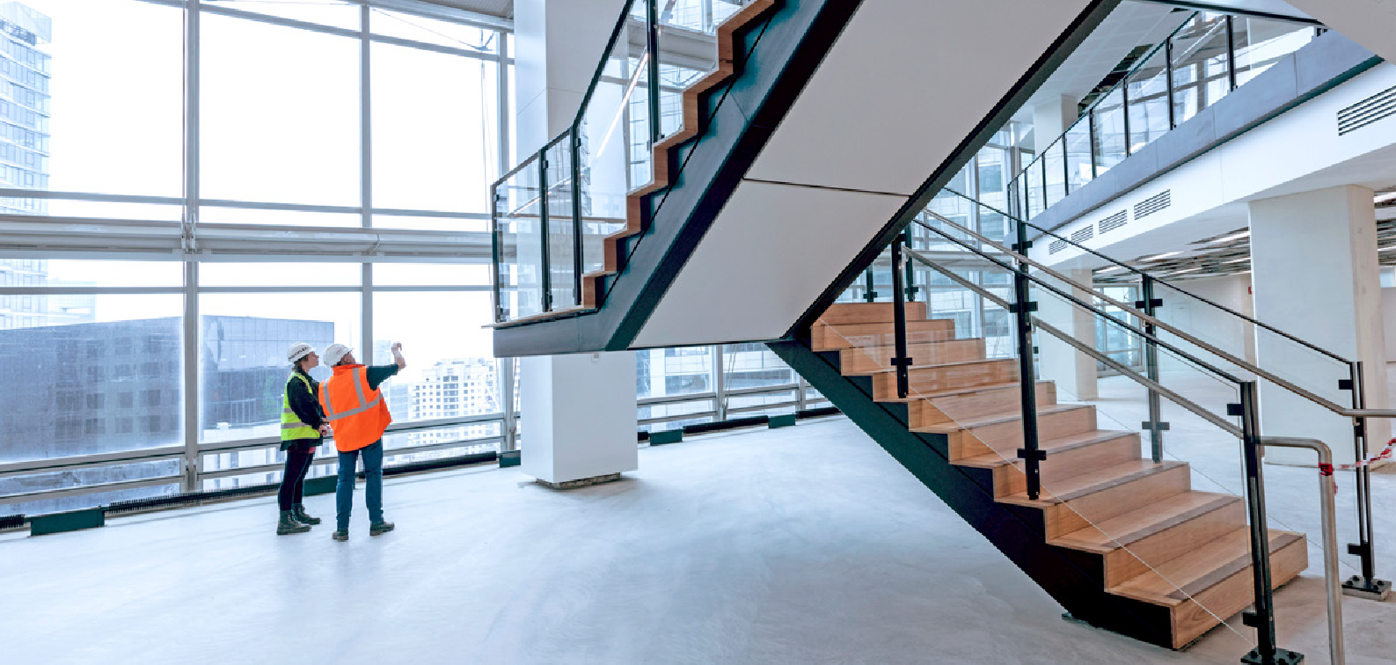

Building services

Building services engineers
A list of preferred base building consultants who we strongly recommend are engaged to design the services to your tenancy are listed on the Tenant Information Manual under the ‘Tenant Fitout’ section.
Engagement of these consultants is due to the extensive knowledge they possess on the existing building services. They may also be able to provide you with an opportunity to save on associated costs.
Please note: these consultants will be engaged at the tenant’s cost to peer review any service designs prepared by others.
Should their works not, in your opinion, prove competitive, please contact the Senior Facilities Manager, in the first instance.
Final interfacing to this base building system, and the programming of the tenancy layout into the buildings system, must be performed by the preferred contractor, at the tenant’s expense.

The following requirements shall be included:


General system modifications
All modifications of control systems, electronic or otherwise, must be approved by and carried out under the direction of the Building Management Team.
All modifications to electrical switch board circuits/schedules shall be updated daily as the work is carried out. On completion of modifications, the electrical contractor is responsible for providing a new electrical circuit legend for the distribution board and a copy for Building Management Team records.


Access hatches
The lessee is responsible for ensuring that Project Managers, Architects, Engineers, Principal Contractor and Sub Contractors coordinate with the Building Management Team, the location of ceiling access panels to provide safe access (in accordance with Occupational Health and Safety requirements) to the ceiling space equipment, whether it be new or existing services requiring regular service, pursuant to Building Regulations (Essential Services).
Access to mechanical fire dampers as a part of the Essential Services maintenance is required on a 5 yearly basis.

Partitions abutting external glass
Where any partition abuts external glass between mullions, the detail must include a channel (slip joint) to allow up to 25mm movement, to not transfer movement or distortion from the partition to the external glass and conversely, not inhibit normal flexing of the external glass.
Where partitions do not land on a mullion, consideration must be given to minimising any future necessary demolition works for the purpose of accessing and replacing broken or failed double glazed units.

Electricity supply sub-metering
Electronic monitoring capable of recording electricity consumption of the premises must also be installed to the tenancy. If the Premises is more than one floor, the monitoring system
must be installed separately for each floor. Smart meters are the preferred mode of electronic monitoring where available. The electronic monitoring must provide information in relation to the consumption and usage pattern of electricity within the Premises.
Consumption data must be provided, in electronic format (e.g. excel, csv), to Investa’s monitoring system within a reasonable time following request by Investa to do so. Installation should be completed in consultation with the Asset Services Team to ensure system compatibility.
Please note that the consumption data will be used for efficiency studies, whole of building NABERS ratings and not for invoicing purposes.
The Building Management Team may (but is not obliged to) share gas, electricity and water usage data in relation to the Building as a whole and in a manner, which does not identify any individual tenant with tenant consent to the use of the data.


Emergency and exit lighting
Emergency and exit lighting is installed on an open plan basis to comply with the requirements of relevant authorities. As a result of the tenancy fitout, further emergency and exit lighting may be required, and any such additional lighting will be at the tenant’s expense and must comply with the requirements of relevant authorities.



Waste and recycling in your tenancy
Industry best practice waste and recycling is important to Investa. All waste must be separated at the source into the relevant standard waste streams within your tenancy. This ensures maximum recycling recovery and disposal, contributing to Investa’s waste and circular economy targets.
At a minimum, the following streams must be included in your fitout and tenancy design:
- Landfill bins.
- Organics recycling.
- Paper and cardboard recycling.
- Container deposit scheme (CDS) (NSW and QLD only).
- Mixed recycling for all non-CDS containers and other mixed recycling.
- Simply Cups coffee cup recycling (see Building Management to order).
- Secure document destruction (this is to be managed by the tenant, noting weight data is to be shared with Building Management on a quarterly basis).
Specialised periodic recycling initiatives held by the building owner include:
- Coffee pod recycling via the Nespresso recycling program (this is to be managed by the tenant, noting weight data is to be shared with Building Management on a quarterly basis).
- Fluoro tube recycling.
- E-waste recycling.
- Hard waste.
Investa are continuously reviewing opportunities to further increase their diversion from landfill. Please contact your Facilities Manager to discuss the additional recycling services in your building where applicable.

Design criteria for waste and recycling systems
You should apply the following design criteria to all new tenancy fitout designs to ensure best practice waste and recycling systems.

No under-desk bins
Under-desk bins are not permitted within Investa buildings as studies have shown that the use of these systems reduce the capture of clean recycling in an office environment.

Open-plan areas
Open-plan office areas should allow for the inclusion of waste and recycling stations and approved signage in various points across each floor or within utility areas. Each waste and recycling station should include the following components:
- Landfill waste bin.
- Paper recycling bin.

Kitchenettes
All kitchen areas should allow for:
- Food organics. (Organics bins to capture food scraps and coffee grounds. Kitchen bench caddy’s are recommended to hold organics. Allocation of the caddy to be placed in an alternative location to the standard bin station, which aids improved and clean recycling.)
- Landfill.
- Mixed recycling.
- Container deposit scheme.
The size of these bins implemented are dependent on the number of staff per floor.

Utility areas
All utility/printer areas should allow for the inclusion of:
- Paper recycling bins (240L) sufficient to meet the number of staff serviced by that utility area.
- Cardboard (flattened) recycling area sufficient to meet the number of staff serviced by that utility area.
- Toner and ink cartridge recycling bins.
- Secure document destruction bins (240L) if the tenant requires this service.
- Landfill bin.

Supply of bins
You are responsible for the supply and maintenance of any bins within the your space.
All bins in the tenancy must be colour coded in accordance with the national waste standard colour coding (refer to signage link below). Within kitchenette areas, designers can consider housing the bins within joinery units.
Where bins are located within joinery units they must remain easily accessible by users to ensure that rubbish/ recycling can be disposed of without physically touching the bin itself. Where joinery enclosures are used, they must:
- Be large enough to house the bin with the lid in an open position.
- Allow for appropriate pictured signage to be displayed.
- Be designed such that the front of the enclosure can be opened to facilitate easy removal of the bin by cleaners.
- Ensure no drawer systems are in place as these do not meet best practice. To reduce contamination, it is recommended an opening is created at the top of the joinery for waste disposal, this will not require staff to touch joinery at any time.

Alternatively, if colour coded pictured lids are introduced inside a bin drawer system this will be compliant. However, it is recommended lid options be investigated before finalising your design.
All joinery designs are to be approved by Investa Facilities Management to ensure these units meet best practice recycling and waste management.
An example of a best practice waste and recycling station is shown below, we recommend method recycling or source separation for your bin stations. Bins are required to have colour-coded lids in line with the national standards.

Signage
All bins and joinery enclosures must be fitted with appropriate signage. Investa standard waste signage is available to download here.

Tenancy bin requirements
Recycling stations or bin hubs are widely accepted in the Commercial Building Office. For best practice recycling recovery please ensure the following is met:
- Ensure waste stations support paper, landfill and mixed recycling in national standard colours.
- Ensure the bin station is in line of sight of your staff where appropriate.
- Implement one station per 20-25 people to ensure waste stations do not exceed capacity.
- Implement organics recycling in kitchens only with a separate kitchen caddy to minimise contamination.
Please contact our friendly Building Management Team to discuss your recycling needs to ensure they meet best practice.
Investa has also developed ‘Binder’ a waste engagement tool styled in the form of a dating app. Learn what common office items are accepted for recycling – and which are to be sent to landfill – while helping the yellow recycling bin find love. You can play Binder here.
This Waste and Recycling section has also been included in the Tenant Fitout Guide that can be shared with your preferred contractor.

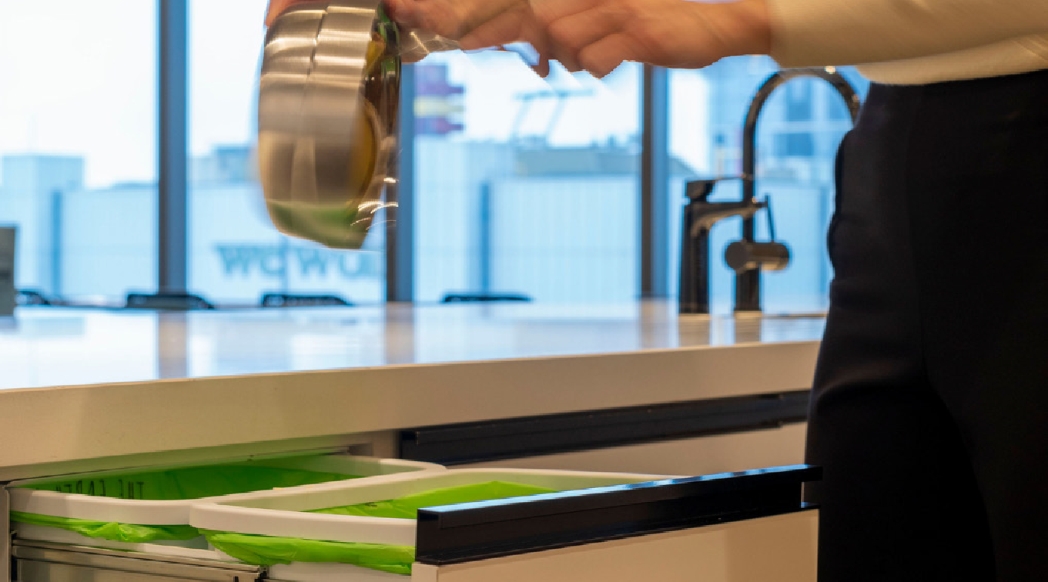



Workplace health and safety
Tenants and their contractors (including sub- contractors and workers engaged by them) must understand and comply with applicable WH&S legislation and associated regulations. Tenants and their contractors will be responsible for ensuring that workers under their control in the workplace (including sub-contractors) comply with applicable WH&S legislation and associated regulations.
When undertaking fitout works, tenants must ensure that:
- Where works are undertaken within the tenancy, that contractors comply with applicable WH&S legislation and associated regulations.
- Where works extend to common areas or base building services (including all equipment that is controlled by the Building Management Team e.g. connections to base building services), that the contractor/worker is required to be inducted and to supply all safety documentation required by the Building Management Team, as if it were conducting works at the request of Investa.
- All works are undertaken in compliance to the Building Safety Instructions.
- Work practices which are unacceptable under, or are in breach of, the terms of applicable WH&S legislation and regulations, will not be tolerated by Investa. Any contractor engaged by a tenant of Investa who fails to observe the provisions of applicable WH&S legislation and any associated regulations, may be required to leave the workplace unless the unacceptable conduct or breach is immediately rectified.

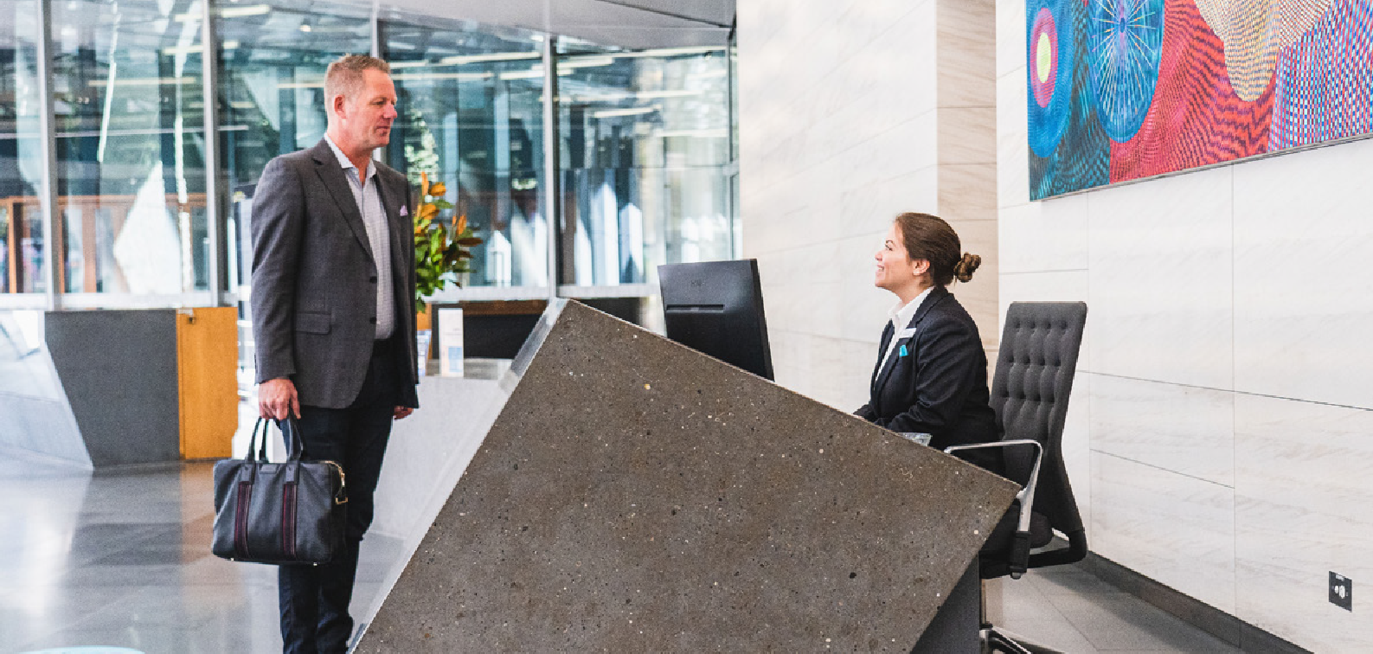

Works undertaken within your tenancy
Works that are conducted within tenancy areas are under the operational control of tenants. As such, it is important to note that the tenant is considered to be a Person Conducting a Business or Undertaking (PCBU) and is responsible for ensuring compliance to WHS Legislation and Regulations for all works undertaken by them or their contractors.
Investa requires at a minimum, contractors (and their workers), engaged by Investa tenants:
- That an appropriate safety management plan is developed, implemented and maintained to ensure a safe workplace is provided.
- Are aware of the requirements set out in this document, including the Investa Building Safety Instructions.
- Provide adequate supervision of Workers (including any sub-contractors, consultants, visitors) to ensure their compliance with applicable WH&S legislation and associated regulations.
- Ensure that all areas where work is undertaken are adequately barricaded from unauthorised access and that appropriate safety signs warning of risks to safety are installed.
- Comply with all instruction issued by Investa in relation to WH&S including the Building Safety Instructions;
- Provide and maintain protective clothing and equipment for their employees and sub-contractors.
- Ensure their employees and sub-contractors are adequately trained for the work they are required to perform and that instructions are given to them in relation to the correct use of protective clothing and equipment.
- Must make arrangements for ensuring safety and absence of risks to health in connection with the use, handling, storage or transport of plant and substances.
- Participate in WH&S consultation meetings/processes as required by Investa.
- Where conducting works on base building services or in base building areas, ensuring compliance to requirements detailed in Works Undertaken Within Base Building Areas.
- Notify the Building Management Team when planning to undertake any works that may require shut down or isolation of any of the following services:
  - Fire Systems.
  - Electrical Systems.
  - Water Systems.
  - Air conditioning systems.
- Ensuring that safe means of access and egress to the work area is maintained.

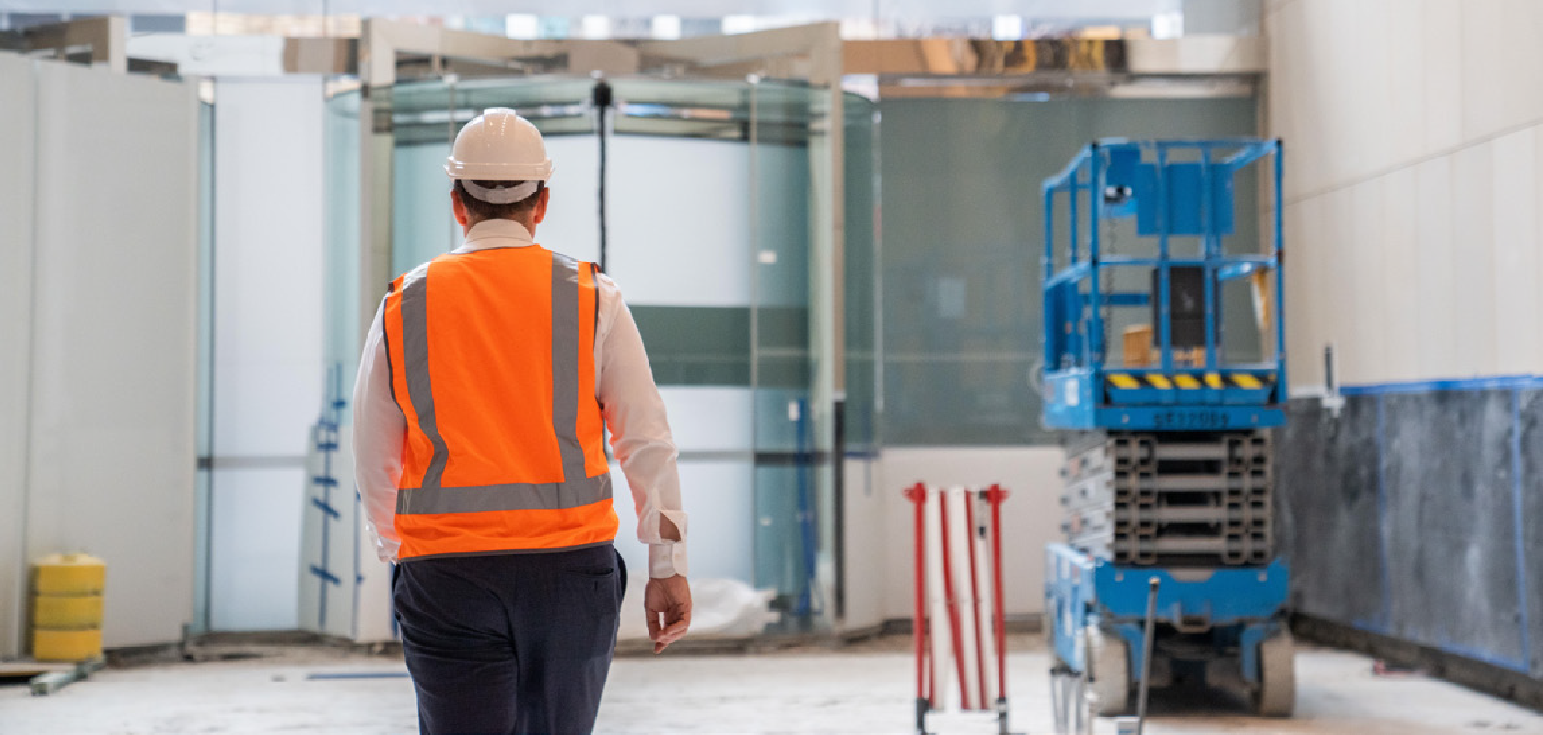

Works undertaken within base building areas
Any works undertaken by tenant contractor’s (or sub-contractors under their control) within base building areas must comply with the base building safety management system. This means that workers must:
- Be inducted to, and acknowledge, Investa’s rules prior to commencing works. This process takes approximately 20 minutes to complete and will only be conducted with prior arrangement.
- Provide Safe Work Method Statements for review and acceptance by the Building Management Team (prior to commencement of work, for all tasks to be undertaken.
- Comply with all reasonable safety directions provided by Investa including the Building Safety Instructions.
- Report any incidents, dangerous occurrences and equipment damage, and any preventative corrective measures implemented to the Building Management Team.
- Are appropriately licensed and/or trained to conduct the works that they are completing.
- Contractors and their workers who fail to observe the provisions of applicable WH&S legislation/regulations may be required to leave the workplace. Workers who do not also comply with any reasonable instructions issued or requested by an Investa employee or their designate, may also be asked to cease works or leave site.
- It is recommended that the base building consultants are engaged by the tenants for Building Certification and Accessibility consultancy services regarding CDC and other Council applications for tenancy fitout works.

Building safety instructions
- The following Building Safety Instructions provide a guide to the requirements of Investa in relation to working in this property. More detailed requirements are specified through the induction process and various operational procedures which can be requested from the Facilities Manager.
- All contractors shall abide by and be bound by the Building Safety Instructions and shall ensure that all workers (including any employees, agents, and sub-contractors) engaged by them are conversant with and abide by the Building Safety Instructions.

Crystalline silica products
- Hazards involving working with products containing crystalline silica are to be identified and controlled. Where possible, silica containing products should be substituted for safer alternatives.
- Uncontrolled dry cutting, grinding, polishing and drilling of any materials containing silica is prohibited. The only acceptable controls for conducting these activities are:
  - An integrated water delivery system containing continuous feed or water, or a local exhaust ventilation (LEV) system with a H class dust collector.
  - A safety management plan must be submitted prior to commencement of any activities involving crystalline silica products.
- Cutting, grinding, polishing and drilling activities are to occur off site if possible. It these activities are to occur on site, the following controls rules apply:
  - Work areas conducting this activity are isolated from other areas.
  - Decontamination procedures are implemented to prevent the spread of dust from isolation zones to other areas.
  - Any contamination occurring outside of the work zone must be cleaned immediately using a H class vacuum cleaner.
  - A dedicated regular cleaning regime must be implemented for any generated dust waste. Dry sweeping and the use of compressed air to clean is prohibited.
  - All workers must wear appropriate breathing protection with a P2 filter as a minimum.
  - Air quality checks must be conducted for the duration of the works with final air monitoring results provided to Investa.
  - All generated waste material and contaminated disposable clothing is the be collected and removed from site by the contractor.

General rules
The Building Safety Instructions are as follows:
- Works must ensure that they do not undertake works, or perform those works in a manner, which will harm the environment. Works will ensure:
  - Substances are not discharged to sinks or pipework which may lead to stormwater or sewer systems.
  - Chemicals are appropriately bunded while stored on-site.
  - Taps and other fixtures are switched off properly.
  - Waste is appropriately recycled.
  - Lights and other energy consuming equipment is switched off when leaving work areas.
- Protection of work areas and safety of the public:
  - Work areas must be appropriately barricaded or cordoned off to reduce risk to others.
  - Passenger lifts in any Investa buildings are not to be used for transporting materials – only the goods lift may be used for this purpose or such other means as is agreed with the Facilities Manager.
- Keys and passes must be signed for by the contractor and returned to the Facilities Manager/Security at completion of the works. The Facilities Manager must be advised in advance of a contractor’s attendance to site or access may be refused.
- Prior to commencing works, contractors and their workers must be adequately prepared in the case of an emergency including:
  - Assessment and planning for emergency scenarios arising out of the works they are completing.
  - Being familiar with the location of fire exits, fire extinguishers, fire phones and fire hoses.

Housekeeping:
- Work areas must be kept clean and tidy and any safety hazards cleaned up promptly by the contractor.
- Fire hazards such as garbage, oily rags and flammable materials must be eliminated by removing it promptly.
- All protruding nails or bolts shall be bent over or removed and all other dangerous objects in any work area shall be removed or protected daily by the contractor.

Personal protective equipment must:
- Be worn by the contractor, its employees and agents (including sub-contractors engaged by the contractor) when necessary or as required by law.
- Be of a suitable standard and maintained to provide adequate protection as required by the works being undertaken.

Where incidents occur:
- Contractors must report all accidents, incidents, dangerous occurrences and equipment damage which occur in the building immediately to the Building Management Team.
- Such notification must be provided immediately or, at the latest, within enough time to notify, as required, any relevant statutory authority of the accident, incident, dangerous occurrence or equipment damage.
- Where a person requires first aid treatment, Security and the Building Management Team must be contacted. The Security and Building Management Team staff and Senior First Aid Attendants are trained and can render treatment.

Where hot works (including welding and grinding) is to be undertaken:
- Ensure that a Hot Works Permit (Appendix 4) is completed and submitted to the Facilities Manager for review and approval prior to undertaking those works.
- Ensure that oxy-acetylene, oxy-LPG cylinders or the like are securely fixed in an approved trolley the right way up. All oxy-acetylene and oxy-LPG equipment and the like shall be equipped with flashback arrestors;
- Welders shall screen to protect others against welding flashes and to prevent the fall of slag.
- Adequate fire protection shall be provided as necessary by the contractor. A suitable fire extinguisher shall be provided by the contractor when electric, oxy-acetylene or oxy-LPG welding plant or equipment are brought into the workplace.

Where conducting electrical works:
- Works will only be conducted by licensed electricians.
- No work to ‘LIVE’ electrical installations is to occur, including work on switchboards, plant and equipment and lighting or power circuits. Any work to electrical equipment must be isolated prior to starting work.
- All electrical equipment is to be considered ‘LIVE’ until isolated by a licensed electrician, and fitted with a danger tag in accordance with Investa’s electrical safety procedures (copies can be provided upon request).
- Danger tags must not be left in place for longer than the working day, without prior permission by the Facilities Manager. Only the person who affixed the danger tag can remove the tag.

Where powered hand tools are used:
- Electric leads shall be connected to the nearest electrical point via portable RCD protective device, not over extended and shall be switched off at the point of power supply and removed when not in use.
- All leads shall be taken from the nearest point of supply, confined to the floor of origin. Power for use in stairwells may be obtained from the floor above or below the workplace. This clause need not apply to lift or service shafts.
- Leads shall be supported clear of floors by use of stands or other suitable means as prescribed, or run through protective covers which in turn do not create a hazard.
- All leads, cords, and power tools are to be tested and tagged in accordance with statutory requirements. Leads, cords and tools with signs of visible damage are not permitted for use within this building and must be removed.
- Explosive power tools shall not be used without the express permission of the Facilities Manager. Proper care shall be taken in use of compressed air or associated equipment shall have safety devices fitted and be operational to manufacturers or authority specification or requirements. Tools, which allow free flight, are required to be approved by the Facilities Manager prior to use.
- No machinery, hand tools or any other type of equipment is to be operated without effective guards. The contractor will be required to modify, guard or remove any plant or equipment provided by the contractor, which does not meet safety requirements and/or relevant laws.
- Where petrol, diesel, or gas powered equipment is used in the workplace, fuel for such equipment shall be stored in accordance with relevant statutory authority requirements and applicable laws in appropriate containers, designed for its storage and adequately protected against fire risks.

When accessing or working in carparks or loading docks:
- Only access carparks and loading docks with express prior permission of the Facilities Manager (generally this will only be allowed after normal working hours).
- Safe speed shall be observed by drivers within the car parks – a maximum of 5 kilometres per hour.

Working at heights:
- All works that present a fall safety risk (including those with use of scaffold, elevated work platforms, ladders, or BMU) must be specifically addressed within the Safe Work Method Statement and in accordance with Investa Procedure 3.07 Gravitational Hazards Procedure which can be sought from the Facilities Manager.
  - All working platforms, suspended or otherwise, shall conform to statutory requirements.
  - All hoists and scaffolding are to be to the Australian Standards or as required by the relevant laws and authorities.
  - Ladders must be of an approved type, extend 1 metre above landing, be set at correct angle of 75 degrees to horizontal, 1:4 fixed top and bottom at all times and regularly inspected and maintained by the contractor. No domestic type, or metal, ladders are to be used.
  - Where no other form of protection is available, full parachute safety harnesses conforming to the Australian Standard shall be worn and properly secured to approved fixing devices. The harnesses must be provided by the contractor.
  - Where there is a danger of tools falling and endangering people working below, only approved lanyards or wrist straps shall be used to secure the tool.
  - All swinging stages must be fitted with sky lock equipment or similar and be supplied with appropriate communications.
  - The use of cranes, scissor lifts, etc., must be in accordance with the manufacturer’s specifications and relevant laws and statutory authority requirements.
  - Contractors are to supply all necessary safety equipment for their employees and sub-contractors use.

Working near cooling towers:
- Workers must not work within the marked 3 metre exclusion zones around cooling towers without wearing P2 masks. It is the contractors responsibility to provide this equipment.
- Where workers are required to pass cooling towers on the way to a specific work area, disposable masks can be requested from the Facilities Manager.

When using hazardous chemicals or dangerous goods:
- Seek approval from the Building Management Team prior to bringing those chemicals/goods into the building.
- Ensure that appropriate Safety Data Sheet (‘SDS’) are kept adjacent to the use and storage areas of any chemicals/goods.
- Managed those chemicals/goods in accordance with the SDS.

Confined spaces:
- Works will not be completed within confined spaces where there is an appropriate alternative.
- Where works can only be conducted from within a confined space:
  - Only certified confined space contractors are permitted to work in confined spaces.
  - Workers must complete a Confined Space Entry Permit for each day’s work. A copy of this can be requested from the Facilities Manager.
  - Workers must provide an appropriate Safety Management Plan in accordance with Investa’s procedure (a copy of this procedure can be provided upon request).
- When conducting noisy work, that work may only be completed with prior arrangement with the Facilities Manager and will only take place outside of normal working hours, with the exception of emergency works.
- Use of lasers (i.e. level lights) in the workplace must be in accordance with statutory requirements.
- Persons affected by alcohol or drugs shall not be permitted to carry out any work on building. The contractor must ensure that any persons employed or engaged by it who are affected by alcohol or drugs are not permitted to work in Investa buildings.
- Smoking is not permitted within this building (including external areas).
- Applicable laws (including legislation and regulations), rules, Codes of Practice and Australian Standards are to be taken as a minimum guide only. Where Investa’s requirements exceed these, they shall be met. Should clarification of these Building Safety Instructions be required, please discuss them with the Building Management Team.

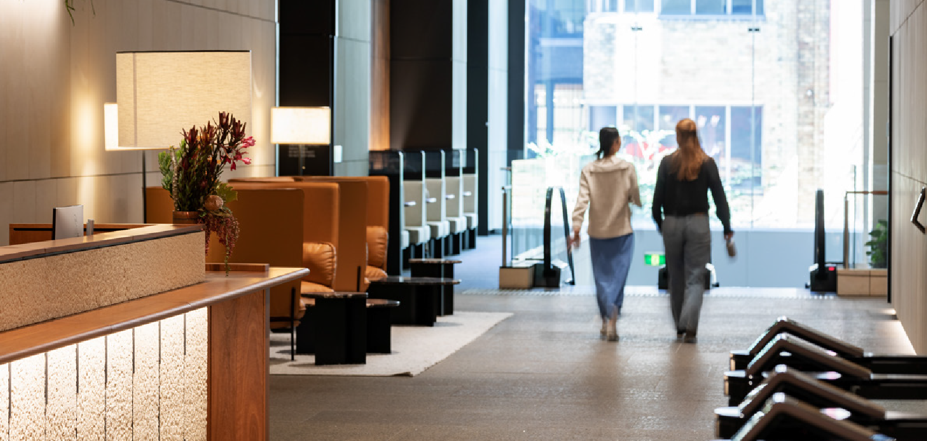

Emergency action

Emergency and exit lighting
Emergency and exit lighting is installed on an open plan basis to comply with authority requirements.
As a result of the tenancy fitout, further emergency and exit lighting may be required, and any such additional lighting will be at the tenant’s expense and must comply with authority requirements.
Tenants should utilise the building computer monitored emergency lighting system (Legrand Axiom System) and only approved fittings are to be installed. Prior to installation fitting must be approved by the Building Management Team.
A certificate of compliance for the tenancy area emergency and exit lighting must be supplied as part of the tenancy Fire and Essential Services documentation.

Emergency Warning and Intercom System (EWIS)
The EWIS amplifiers allow for a maximum speaker load of 10W per floor. This includes common area. Therefore the quantity and type of speakers and the individual tapping thereof shall be selected accordingly in order to;
- Ensure that the total load does not exceed the amplifier rating.
- The requirements of AS2220.2, in particular Section 2.2.3, are maintained.
Typically, speakers installed in general office locations will utilise transformer tapping no greater than ½ watt.
Installation or modification to an existing installation is to be in strict accordance with the requirements of AS2220.2, paying particular attention to clauses 5.2.5 and 5.3 which refer to correct speaker terminations. Under no circumstances are “starred” wiring configurations of speaker circuits permitted.
At the completion of any tenancy fitout works that have involved alteration of the speaker circuit in any way, the builder shall arrange for a full functional test to be conducted prior to occupancy. This is to be conducted by Investa’s current fire services contractor who shall be required to provide the Building Management Team with a report detailing the measured total floor speaker loading and a statement to confirm that the final installation is in compliance with the requirements of AS2220.2.

At the completion of any tenancy fitout works that has not involved alteration of the speaker circuit in any way, the builder shall arrange for a functional test only, to be conducted prior to occupancy. This is to ensure the speaker circuit has not been inadvertently compromised in any way during the fitout works.
Any testing involving activation of the EWIS panel shall be coordinated directly with the Building Management Team.

Noise and odour control
No noisy works such as drilling, jack hammering, demolition, core holing or cutting of penetrations shall take place between the hours of 7:30am to 6:30pm Monday to Friday. This includes all hammer type drills. Written approval must be obtained for coring and other penetrations from the structural engineers, stating that
the proposed work will not have any detrimental effect on the structure. Approval must be presented to the Building Management Team before any work commences.
Any other works causing discomfort to adjacent tenants shall cease immediately upon request of the Building Management Team and shall only resume after normal working hours.

Explosive power tools
Explosive power tools shall not be used in the building without the consent of the Building Management Team. Such consent would be dependent on the hazard identification and risk assessment audit and appropriate control measures to be implemented by the head contractor.

Offensive odours
Painting and floor covering installations involving adhesives producing offensive odours which may be drawn into the air conditioning system and affect other occupants, must be done outside normal office hours at the discretion of the Building Management Team. Smoke detector isolations must be arranged prior to painting works being performed.

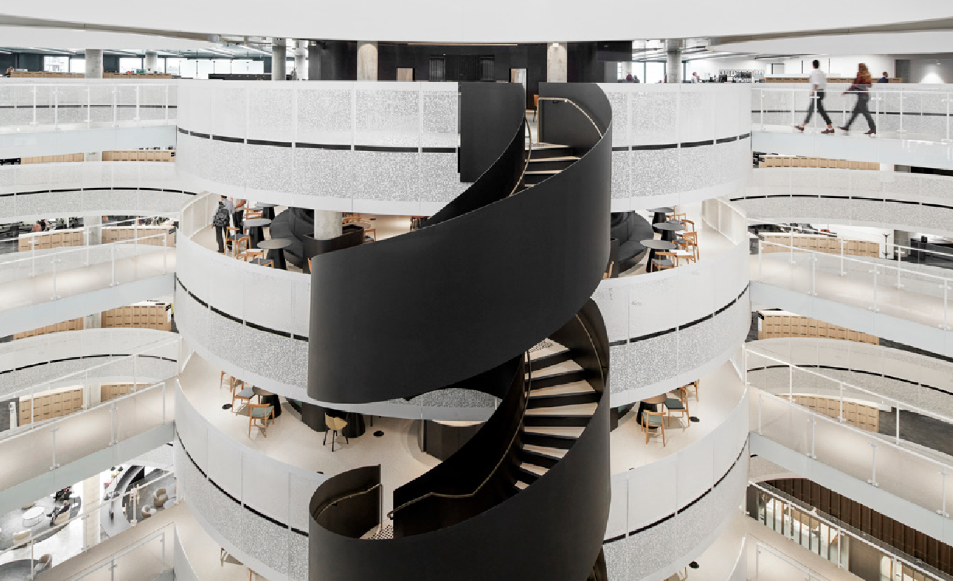

Fitout checklist

Pre Fitout Requirement  Lease or licence agreement must be completed (to be confirmed by GM/PM) | Compulsory  Yes or No  Yes No | Investa’s  Confirmation Date
Lease documentation or Heads of Agreement owner securities (e.g. Insurance, bank guarantee, performance bond) | Yes No
The Tenant Project Manager has been issued with the property Fitout Guide, Tenant Information Pack and House Rules | Yes No
The Tenant Project Manager confirms in writing that s/he has received, read and understood the Fitout Guide, Tenant Information Pack and House Rules | Yes No
Contractor Induction and Site Access
The Tenant Project Manager has met with the Landlords site representative | Yes No
The Tenant Project Manager has attended the site induction and is familiar with the contractor site access requirements | Yes No
The Landlord has received a Site Safety Manual from the Tenants Project Manager | Yes No
Dilapidation Report
Report completed and area inspected by Investa FM and Tenant representative | Yes No
Items to be rectified and party responsibility agreed (refer to Heads of Agreement or lease) | Yes No
Authority Certification (attach copies of) | Yes No
Compulsory DA/CC or CDC
Regulatory Authority DA Approval | Yes No
Regulatory or Private Certifier CDC Approval | Yes No
Regulatory or Private Certifier CC Approval | Yes No
Regulatory or Private Certifier Certificate of Occupancy | Yes No
Services Contractor and Consultant Certification
Note: Refer to Section 10, the Fitout Guide for specific services consultant requirements
Preliminary Fitout Approval
The Tenant Project Manager provides Indicative fitout drawings to the Landlord | Yes No
Preliminary approval is given in writing by the Landlords representative | Yes No
Electricity account changed to tenant name | Yes No
Note: Works within Lobby/Common Areas are to submitted in a separate package which will be subject to separate approval
Conditional Fitout Approval
Services drawings are provided for review by Building Management and Base Building consultants:
- Mechanical | Yes No
- Fire | Yes No
- Hydraulic | Yes No
- Electrical (inc. Security) | Yes No
- Structural | Yes No
Architectural drawings are provided for review by Building Management and Base Building consultants | Yes No
Signage plans submitted to Investa (if applicable) | Yes No
Note: Works within Lobby/Common Areas are to submitted in a separate package which will be subject to separate approval

Compulsory Yes or No
Investa’s Confirmation Date

Conditional Approval is provided in writing to the Tenant Project Manager | Yes | No
Tenant Project Manager responds in writing to any concerns raised in the Letter of Conditional Approval | Yes | No
Final Fitout Approval
Landlord provides Final Approval in writing to the Tenant Project Manager subject to a suitable written response to any concerns identified during the Conditional Fitout Approval process | Yes | No
Tenant Project Manager provides Building Permit for Fitout works | Yes | No
Completion of Fitout Works
Mechanical
Tenancy consultant installation and commissioning review completed | Yes | No
Base Building consultant installation and commissioning review completed as noted in Section 10.5 of the Fitout Guide | Yes | No
Note: Final air balance commissioning figures are required to be included in “As Built” documentation
Electrical
Tenancy consultant installation and commissioning review completed | Yes | No
Base Building consultant installation and commissioning review completed as noted in Section 10.5 of the Fitout Guide | Yes | No
Note: Certification must cover emergency lighting and exit signage as noted in Section 8.5 Emergency and Exit Lighting
Hydraulic
Tenancy consultant installation and commissioning review completed | Yes | No
Base Building consultant installation and commissioning review completed as noted in Section 10.5 of the Fitout Guide | Yes | No
Note: Include structural engineering approval and fire/water sealing certification of penetrations
Fire/Essential Services
Tenancy consultant installation and commissioning review completed | Yes | No
Base Building consultant installation and commissioning review completed as noted in Section 10.5 of the Fitout Guide | Yes | No
Note: Certification for fire sprinklers, hydrant, hose reel (if applicable) and EWIS are required from the Base Building contractors and/or consultant. Details nominated in Section 8.5
BMCS
Tenancy consultant installation and commissioning review completed | Yes | No
Base Building consultant installation and commissioning review completed as noted in Section 10.5 of the Fitout Guide | Yes | No
Note for Property Manager: Ensure Building Management’s Operation & Maintenance Manuals are updated with supplementary information for tenancy connections
Architectural
Tenant Project Manager signs off completed works | Yes | No
Building Management sign off by GM, FM, PS | Yes | No
“As Installed” Service Drawings | Yes | No
Mechanical Services (including commissioning detail) | Yes | No

Compulsory Yes or No
Investa’s Confirmation Date

- Light Circuit layout
- Power Circuit layout
- Distribution board (including DB schedule)
- Certification of emergency and exit lighting”
Yes No
Yes No
Yes No
Yes No
Fire Protection, Sprinkler, Hydrant and Hose Reel
(including Base Building contractor sign off) BMCS (including Base Building contractor sign off) Reflected Ceiling
Partition Layout
Applicable Certification (including but not limited to):
- Certificate of Electrical Safety
- Plumbing Certificate of Compliance
- Certificate of Occupancy/Certificate of Final Inspection
Note: It is required that all drawings are supplied as required in the property Fitout Guide. As a minimum this will include two copies of hard copy plans and an electronic version in PDF and auto CAD format.
Yes No
Yes
Yes Yes Yes Yes Yes Yes
No
No No No No No No
Hydraulic
Electrical

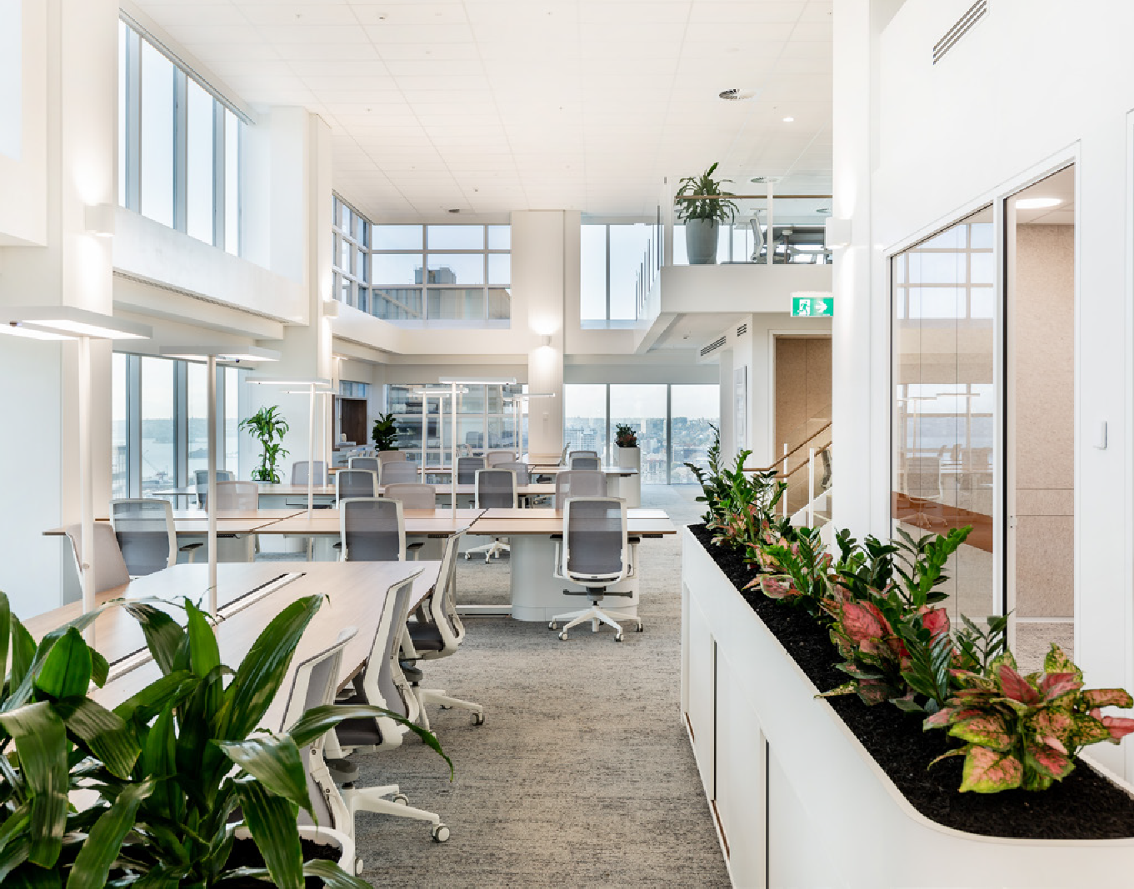

Disclaimer
Investa and its Agents take no responsibility for any errors or omissions or discrepancies, if any, in this document, which have been compiled from information supplied to us by various sources and are subject to withdrawal and or change without notice. This is a guide only and it remains the responsibility of the tenant or prospective tenant to make their own enquiries to ensure validity and accuracy of such information contained herein.

Investa | Tenant Fitout and Minor Alterations Guide 29

